**Noise Power**

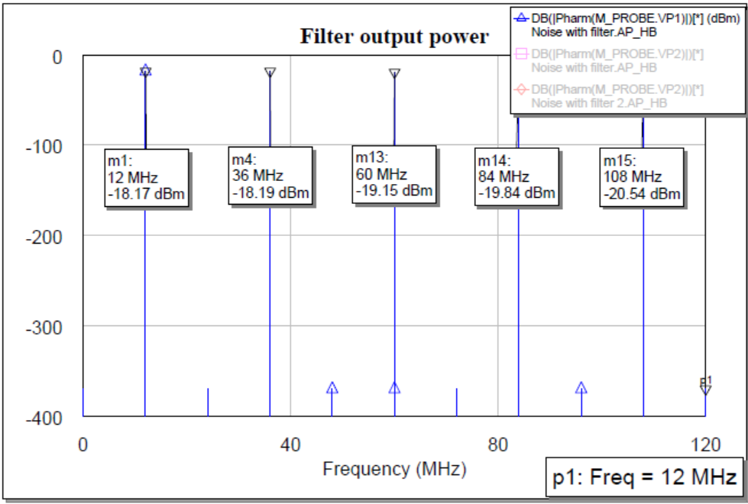

**Filter Output (except Cx and Cy capacitor)**

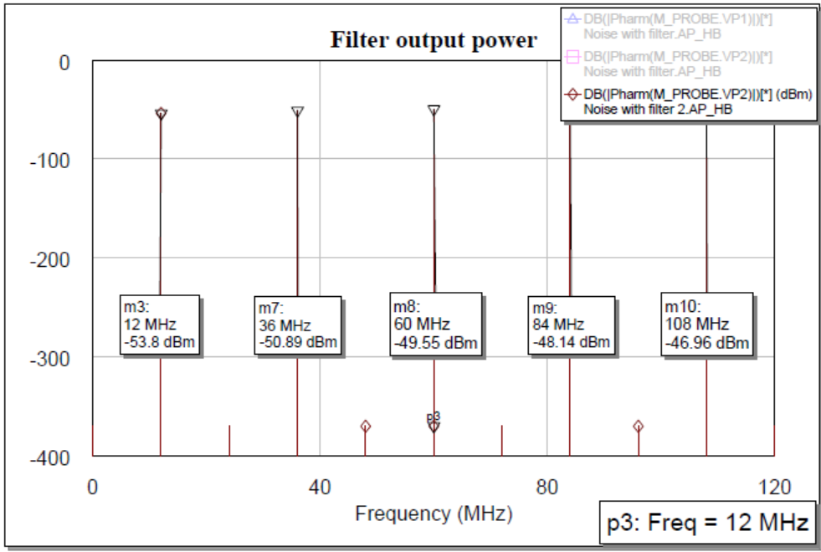

**Filter output (Cx=800,400pF; Cy=20pF) Filter output (Cx=0.1µF; Cy=20pF)**

